A Project report on

A Multilingual Spam Reviews Detection Based on Pre-Trained Word Embedding and Weighted Swarm Support Vector Machines
A Dissertation submitted to JNTU Hyderabad in partial fulfillment of the academic requirements for the award of the degree.
Bachelor of Technology
in
Computer Science and Engineering (AI&ML)
Submitted by

LUKALAPU YASHWANTH (23H51A6638)
MADAGONI GOWTHAM (23H51A6639)
MARAMWAR SAHITHI (23H51A6644)
Under the esteemed guidance of Dr.Y.Ambica
(Assistant Professor)

Department of Computer Science & Engineering (AI&ML)

CMR COLLEGE OF ENGINEERING & TECHNOLOGY
(UGC Autonomous)
*Approved by AICTE *Affiliated to JNTUH *NAAC Accredited with A⁺ Grade
KANDLAKOYA, MEDCHAL ROAD, HYDERABAD - 501401.

2025- 2026

CMR COLLEGE OF ENGINEERING & TECHNOLOGY
KANDLAKOYA, MEDCHAL ROAD, HYDERABAD – 501401

DEPARTMENT OF COMPUTER SCIENCE AND ENGINEERING(AI&ML)


CERTIFICATE

This is to certify that the Industry Oriented Mini Project(A466802) report entitled "A Multilingual Spam Reviews Detection Based on Pre-Trained Word Embedding and Weighted Swarm Support Vector Machines" being submitted by Lukalapu Yashwanth (23H51A6638),Madagoni Gowtham (23H51A6639), Maramwar Sahithi (23H51A6644) in partial fulfillment for the award of Bachelor of Technology in Computer Science & Engineering(AI&ML)is a record of Bonafide work carried out his/her under my guidance and supervision.
The results embodies in this project report have not been submitted to any other University or Institute for the award of any Degree.

Dr.Y.Ambica  Assistant Professor | Dr. S.Kirubakaran  Professor and HOD | External Examiner
Dept.of CSE(AI&ML) | Dept. of CSE(AI&ML)

ACKNOWLEDGEMENT

With great pleasure we want to take this opportunity to express my heartfelt gratitude to all the people who helped in making this project work a grand success.
We are grateful to Dr.Y.Ambica, Assistant Professor, Department of Computer Science and Engineering(AI&ML) for his/her valuable technical suggestions and guidance during the execution of this project work.
We would like to extend our heartfelt gratitude to our Project Coordinator, Mrs.Ruquia Taha, Assistant Professor for their mentorship, patience, and support. Their guidance allowed us to navigate complex issues and reach our project goals.
We would like to thank Dr. S.Kirubakaran, Head of the Department of Computer Science and Engineering(AI&ML), CMR College of Engineering and Technology, who is the major driving forces to complete my project work successfully.
We are very grateful to Dr. P.Ravi Kumar, Dean-FSA, CMR College of Engineering and Technology, for his constant support and motivation in carrying out the project work successfully.
We are very grateful to Dr. Ghanta Devadasu, Dean-Academics, CMR College of Engineering and Technology, for his constant support and motivation in carrying out the project work successfully.
We extend our heartfelt gratitude to Dr.Seshu Kumar Avadhanam, Principal, CMR College of Engineering and Technology, for his unwavering support and guidance in the successful completion of our project and his encouragement has been invaluable throughout this endeavor.
We are highly indebted to Major Dr. V A Narayana,Director, CMR College of Engineering and Technology, for giving permission to carry out this project in a successful and fruitful way.
We express our sincere thanks to Shri. Ch. Gopal Reddy, Secretary& Correspondent, CMR Group of Institutions, and Shri Ch Abhinav Reddy, CEO, CMR Group of Institutions for their continuous care and support.
We would like to thank the Teaching & Non- teaching staff of Department of Computer Science and Engineering (AI&ML) for their co-operation.
Finally, We extend thanks to our parents who stood behind us at different stages of this Project. We sincerely acknowledge and thank all those who gave support directly and indirectly in completion of this project work.

Lukalapu Yashwanth 23H51A6638 Madagoni Gowtham 23H51A6639 Maramwar Sahithi 23H51A6644

DISPLAYING EMOJI BASED FACIAL
EXPRESSION

ABSTRACT

There are many different ways to express and communicate our feelings. The two classified ways of communication are verbal and non - verbal. Facial expressions are a great way of communication involving the exchange of wordless intimations.
It has enticed much research attention in the field of computer vision and Artificial intelligence.
Many kinds of research have been done for grouping these expressions.
It is chiefly done to acquire the sentiments of humans. In this project, an API can be employed to fetch images from any camera-based application in real time.
HAAR cascade classifier is employed to extract the image features from the images fetched earlier.
Support Vector Machines (SVM) is used to classify those features into corresponding expressions. And these expressions are then converted to their equivalent emoji, after that these emoji, are get superimposed over the actual face expression as a mask.
This project can be used to study the different facial expressions that a machine can understand and also it can be used as a filter used in social media apps like Facebook, Instagram, snapchat etc.

INDEX
- INTRODUCTION 6-7
  - OVERVIEW 6
  - EXISTING SYSTEM 6
  - PROPOSED SYSTEM 7
- LITERATURE REVIEW 9
2.1. SYSTEM SPECIFICATION 8
2.2. SYSTEM STUDY 9
3. METHODOLOGY 10
  - MODULE 10
3.2. ALGORITHM 10

4. UML DIAGRAMS 11-18
4.1 ARCHITECTURE DIAGRAM 11
4.2 COMPONENT DIAGRAM 12
4.3 ER DIAGRAM 13
4.4 USE CASE DIAGRAM 14
4.5 CLASS DIAGRAM 15
4.6 DATA FLOW DIAGRAM 16
4.7 ACTIVITY DIAGRAM4. 17
4.8 SEQUENCE DIAGRAM 18

5. IMPLEMENTATION 19- 31
5.1 TECHNOLOGIES USED 19
5.2 INTRODUCTION TO PYTHON 20-23
5.3 DJANGO 24-31

6. SOFTWARE INSTALLATION 32-35
7. CODING 36-42
8. TESTING 43-46
9. RESULT 47-53
10. CONCLUSION 54

11.REFERENCES 54

LIST OF FIGURES

Fig 4.1 Architecture diagram 12

Fig 4.2. Component Diagram 13

Fig 4.3 ER Diagram 14

Fig 4.4 Use case Diagram 15

Fig 4.5 Class Diagram 16

Fig 4.6 Data flow diagram 17

Fig 4.7 Activity Diagram 18

Fig 4.8 Sequence Diagram 19

Fig 9.1 Output Screen-1 47

Fig 9.2 Output Screen-2 48

Fig 9.3 Output Screen-3 49

Fig 9.3 Output Screen-4 50

Fig 9.3 Output Screen-5 51

Fig 9.3 Output Screen-6 52
Fig 9.3 Output Screen-7 53

vi

CHAPTER – 1

INTRODUCTION
1.1 OVERVIEW

Communication is an important act of exchanging information between two different persons or groups. The person sending the information is referred as sender while the person acquiring the information is referred as receiver. The non-verbal communication of messaging involves the exchange of wordless cues. “Nonverbal communication is ubiquitous.”[1].They are always present in every communication process. It comprises of 93% of human communication and in this 55% consists of human gestures and actions [2]. Facial expressions like Laughing, crying, staring and body gestures like pointing, crossed-legs and some of the hand gestures like thumbs signals are some of the non-verbal communications. By looking at someone’s facial expression, we can comprehend the other person’s feelings. These non-verbal signs give more insights and meaning that is not provided by the verbal communication. A major chunk of non-verbal communication involves the facial emotions exhibited by a person. Emotions represent the mental state along with the facial expressions, actions or any physical changes.

  - EXISTING SYSTEM

The current systems are mostly based on neural networks which need require large number of datasets for computation. Designing of these neural networks are mathematically complex in nature.
The processing and testing time if these networks consume a lot of time. Though they depict quite efficient results for the static images, their real time processing is low.
For facial features extraction, the various machine learning algorithms such as Viola-Jones, HOG are used that are not as efficient as HAAR- Like features.
Viola jones is slow in processing of image while HOG is for quality. HOG collects noisy information like background, blur, rotation changes and lighting of the entire image and followed by the generation of Histogram.

  - PROPOSED SYSTEM

The idea of the proposed system is to employ an API that will detect the face after which the image can be processed using HAAR cascade for facial feature extraction. SVM Classifier is then used to categorize the emotions into its seven distinct types. Using HAAR of Open CV package, the corresponding emoji of the emotions can get superimposed over the subjects’ faces.

In any camera module of any leading social networking apps, the use of APIs can reduce the processing time for face detection for which they have their in-built face detection algorithm which can detect the face smoothly and followed by which the emoticons can be implemented over the faces as filters.

However, this simple fast and playful rating system should give a wider range of opinions about the experiences of the customers with the restaurant concept. Last but not the least, human expressive behaviors in realistic applications involve encoding from different perspectives, and the facial expression is only one modality.

Although pure expression recognition based on visible face images can achieve promising results, incorporating with other models into a high-level framework can provide complementary information and further enhance the robustness.

For example, participants in the Emoji challenges and Audio Video Emotion Challenges (AVEC) [252], [253] considered the audio model to be the second most important element and employed various fusion techniques for multimodal affect recognition. Additionally, the fusion of other modalities, such as infrared images, depth information from 3D face models and physiological data, is becoming a promising research direction due to the large complementarity for facial expression

CHAPTER - 2

LITERATURE REVIEW

We started by selecting databases. With reference to the major platforms for related publications, we chose Web of Science and Google Scholar as literature sources. On August 3rd, 2019, we searched Google Scholar and Web of Science using “emoji” as the key word for related literature in English since 1998. Patents, news, book reviews, editorials, letters, and other literature types were excluded and the two databases were combined. After getting rid of the duplicates, we got 167 papers published in 78 journals and and delivered at 33 conferences. We summarized the list of journals and conferences that published articles on emoji more than once, as shown in Table 1. In addition, due to the extensive use of emoji in social networks, we also referred to as https://emojipedia.org/, https://www.reddit.com/r/EmojiReview/. In this paper, the above contents were summarized and reviewed.

2.1 SYSTEM STUDY

Hardware Requirements

- System : Pentium IV 2.4 GHz.
- Hard Disk : 40 GB.
- Floppy Drive : 1.44 Mb.
- Monitor : 15 VGA Colour.
- Mouse : Logitech.
- Ram : 512 Mb.

Software Requirements

- Operating System: Windows
- Coding Language: Python 3.7

  - SYSTEM SPECIFICATION
To provide flexibility to the users, the interfaces have been developed that are accessible through a browser. The GUI’S at the top level have been categorized as
- Administrative user interface
- The operational or generic user interface

The ‘administrative user interface’ concentrates on the consistent information that is practically, part of the organizational activities and which needs proper authentication for the data collection. These interfaces help the administrators with all the transactional states like Data insertion, Data deletion and Date updation along with the extensive data search capabilities.
The ‘operational or generic user interface’ helps the end users of the system in transactions through the existing data and required services. The operational user interface also helps the ordinary users in managing their own information in a customized manner as per the included flexibilities.

CHAPTER - 3

METHODOLOGY

3.1 MODULES

Preliminary investigation examines project feasibility; the likelihood the system will be useful to the organization. The main objective of the feasibility study is to test the Technical, Operational and Economical feasibility for adding new modules and debugging old running system. All systems are feasible if they are given unlimited resources and infinite time. There are aspects in the feasibility study portion of the preliminary investigation:
- Technical Feasibility
- Operation Feasibility
- Economical Feasibility

3.2 ALGORITHM

The technical issue usually raised during the feasibility stage of the investigation includes the following:
- The necessary technology exists to do what is suggested?
- Do the proposed equipment have the technical capacity to hold the data required to use the new system?
- Will the proposed system provide adequate response to inquiries, regardless of the number or location of users?
- Can the system be upgraded if developed?
Are there technical guarantees of accuracy, reliability, ease of access and data security?

CHAPTER -4

UML DIAGRAMS

UML stands for Unified Modeling Language. UML is a standardized general-purpose modeling language in the field of object-oriented software engineering. The standard is managed, and was created by, the Object Management Group.
The goal is for UML to become a common language for creating models of object oriented computer software. In its current form UML is comprised of two major components: a Meta-model and a notation. In the future, some form of method or process may also be added to; or associated with, UML.
The Unified Modeling Language is a standard language for specifying, Visualization, Constructing and documenting the artifacts of software system, as well as for business modeling and other non-software systems.
The UML represents a collection of best engineering practices that have proven successful in the modeling of large and complex systems.
The UML is a very important part of developing objects oriented software and the software development process. The UML uses mostly graphical notations to express the design of software projects.

GOALS:
The Primary goals in the design of the UML are as follows:
- Provide users a ready-to-use, expressive visual modeling Language so that they can develop and exchange meaningful models.
- Provide extendibility and specialization mechanisms to extend the core concepts.
- Be independent of particular programming languages and development process.
- Provide a formal basis for understanding the modeling language.
- Encourage the growth of OO tools market.
- Support higher level development concepts such as collaborations, frameworks, patterns and components.
- Integrate best practices.

4.1 ARCHITECTURE DIAGRAM

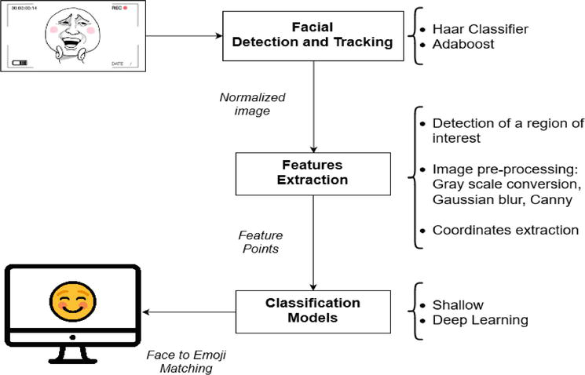

Fig: 4.1 architecture diagram

4.2 COMPONENT DIAGRAM

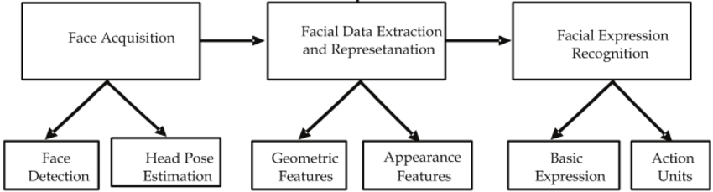

Fig 4.2 component Diagram (Admin)

4.3 ER DIAGRAM

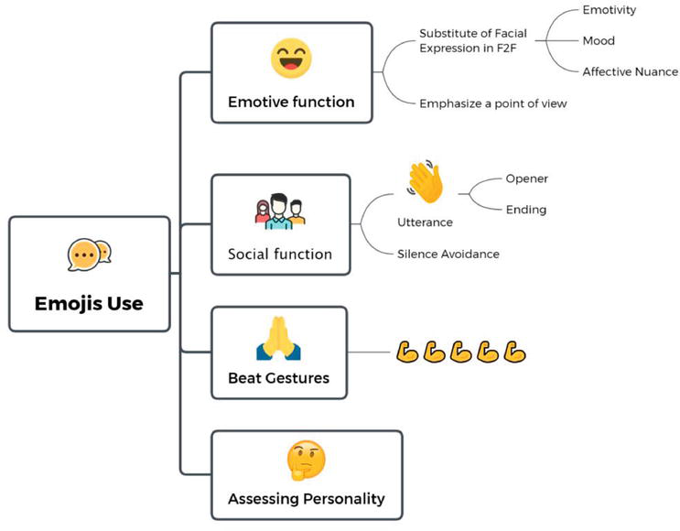

Fig 4.3 ER Diagram

4.4 USE CASE DIAGRAM

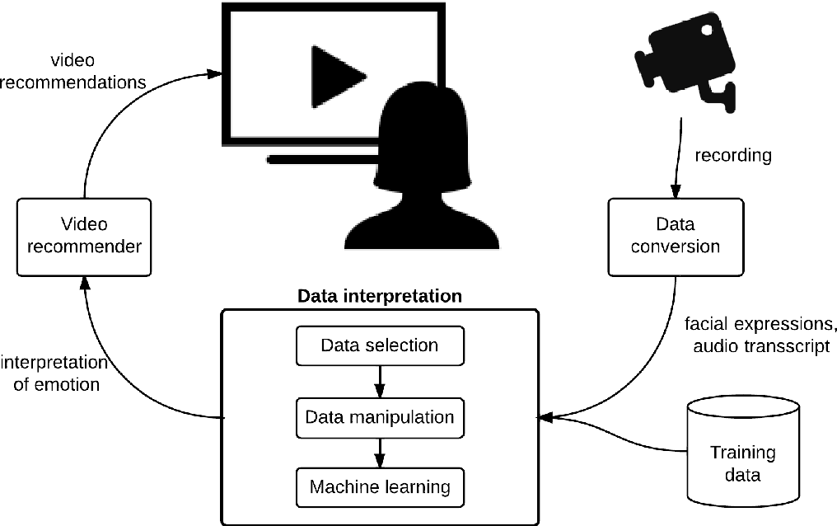

Fig 4.4 use case Diagram

4.5 CLASS DIAGRAM

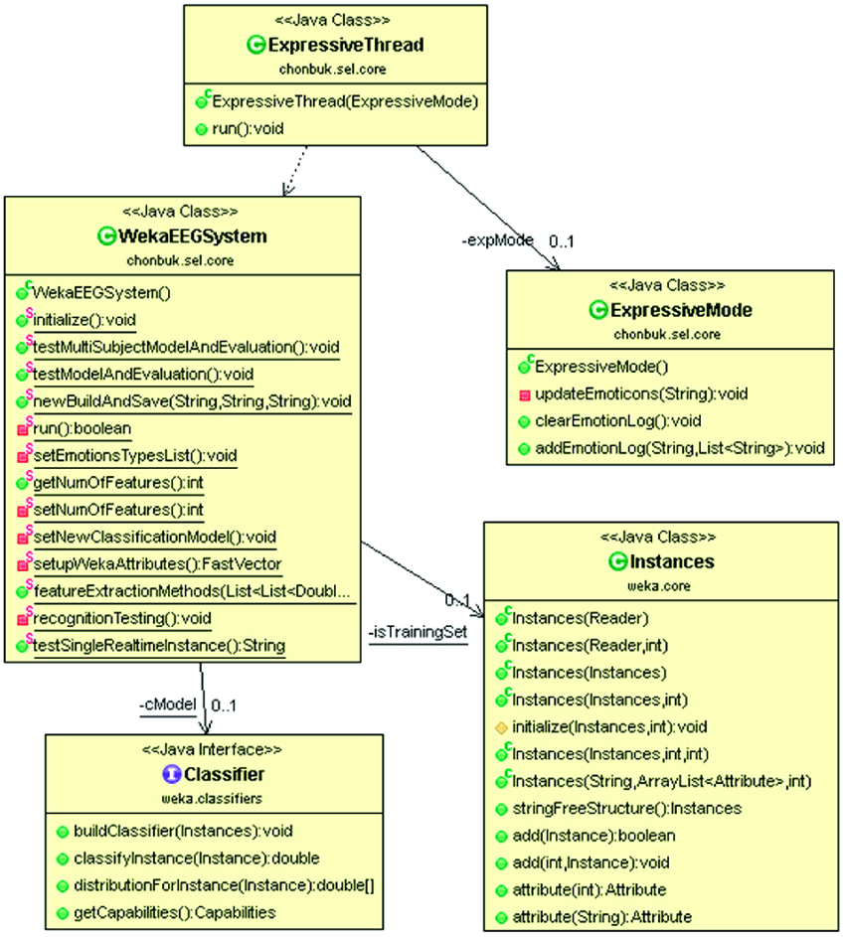

Fig 4.5 Class Diagram
4.6 DATA FLOW DIAGRAM



Fig 4.6 Data Flow Diagram

4.7 ACTIVITY DIAGRAM

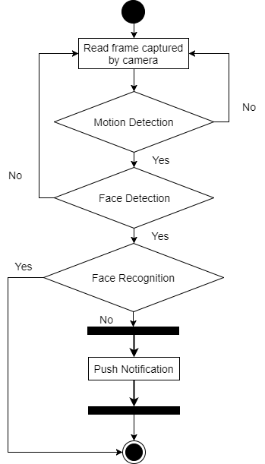

Fig 5.7 Activity Diagram

4.8 SSEQUENCE DIAGRAM

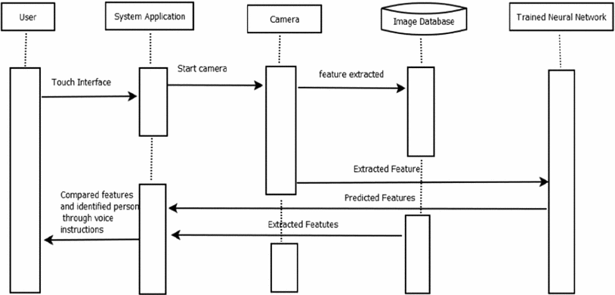

Fig 4.8 Sequence Diagram

CHAPTER -5

IMPLEMENTATION

5.1 TECHNOLOGIES USED

5.1.1 INTRODUCTION TO PYTHON

What is Python :-

Below are some facts about Python.
Python is currently the most widely used multi-purpose, high-level programming language.
Python allows programming in Object-Oriented and Procedural paradigms. Python programs generally are smaller than other programming languages like Java.
Programmers have to type relatively less and indentation requirement of the language, makes them readable all the time.
Python language is being used by almost all tech-giant companies like – Google, Amazon, Facebook, Instagram, Dropbox, Uber… etc.
The biggest strength of Python is huge collection of standard library which can be used for the following –
- Machine Learning
- GUI Applications (like Kivy, Tkinter, PyQt etc. )
- Web frameworks like Django (used by YouTube, Instagram, Dropbox)
- Image processing (like Opencv, Pillow)
- Web scraping (like Scrapy, BeautifulSoup, Selenium)
- Test frameworks
- Multimedia

Advantages of Python :-
Let’s see how Python dominates over other languages.

1. Extensive Libraries
Python downloads with an extensive library and it contain code for various purposes like regular expressions, documentation-generation, unit-testing, web browsers, threading, databases, CGI, email, image manipulation, and more. So, we don’t have to write the complete code for that manually.

2. Extensible
As we have seen earlier, Python can be extended to other languages. You can write some of your code in languages like C++ or C. This comes in handy, especially in projects.

3. Embeddable
Complimentary to extensibility, Python is embeddable as well. You can put your Python code in your source code of a different language, like C++. This lets us add scripting capabilities to our code in the other language.

4. Improved Productivity
The language’s simplicity and extensive libraries render programmers more productive than languages like Java and C++ do. Also, the fact that you need to write less and get more things done.

5. IOT Opportunities
Since Python forms the basis of new platforms like Raspberry Pi, it finds the future bright for the Internet Of Things. This is a way to connect the language with the real world.

6. Simple and Easy
When working with Java, you may have to create a class to print ‘Hello World’. But in Python, just a print statement will do. It is also quite easy to learn, understand, and code. This is why when people pick up Python, they have a hard time adjusting to other more verbose languages like Java.

7. Readable
Because it is not such a verbose language, reading Python is much like reading English. This is the reason why it is so easy to learn, understand, and code. It also does not need curly braces to define blocks, and indentation is mandatory. This further aids the readability of the code.

8. Object-Oriented
This language supports both the procedural and object-oriented programming paradigms. While functions help us with code reusability, classes and objects let us model the real world. A class allows the encapsulation of data and functions into one.

9. Free and Open-Source
Like we said earlier, Python is freely available. But not only can you download Python for free, but you can also download its source code, make changes to it, and even distribute it. It downloads with an extensive collection of libraries to help you with your tasks.

10. Portable
When you code your project in a language like C++, you may need to make some changes to it if you want to run it on another platform. But it isn’t the same with Python. Here, you need to code only once, and you can run it anywhere. This is called Write Once Run Anywhere (WORA). However, you need to be careful enough not to include any system-dependent features.

11. Interpreted
Lastly, we will say that it is an interpreted language. Since statements are executed one by one, debugging is easier than in compiled languages.
Any doubts till now in the advantages of Python? Mention in the comment section.

Disadvantages of Python:-

So far, we’ve seen why Python is a great choice for your project. But if you choose it, you should be aware of its consequences as well. Let’s now see the downsides of choosing Python over another language.

1. Speed Limitations
We have seen that Python code is executed line by line. But since Python is interpreted, it often results in slow execution. This, however, isn’t a problem unless speed is a focal point for the project. In other words, unless high speed is a requirement, the benefits offered by Python are enough to distract us from its speed limitations.

2. Weak in Mobile Computing and Browsers
While it serves as an excellent server-side language, Python is much rarely seen on the client-side. Besides that, it is rarely ever used to implement smartphone-based applications. One such application is called Carbonnelle.
The reason it is not so famous despite the existence of Brython is that it isn’t that secure.

3. Design Restrictions
As you know, Python is dynamically-typed. This means that you don’t need to declare the type of variable while writing the code. It uses duck-typing. But wait, what’s that? Well, it just means that if it looks like a duck, it must be a duck. While this is easy on the programmers during coding, it can raise run-time errors.

4. Underdeveloped Database Access Layers
Compared to more widely used technologies like JDBC (Java DataBase Connectivity) and ODBC (Open DataBase Connectivity), Python’s database access layers are a bit underdeveloped. Consequently, it is less often applied in huge enterprises.

5. Simple
No, we’re not kidding. Python’s simplicity can indeed be a problem. Take my example. I don’t do Java, I’m more of a Python person. To me, its syntax is so simple that the verbosity of Java code seems unnecessary.
This was all about the Advantages and Disadvantages of Python Programming Language.

5.2 DJANGO
Django is a high-level Python Web framework that encourages rapid development and clean, pragmatic design. Built by experienced developers, it takes care of much of the hassle of Web development, so you can focus on writing your app without needing to reinvent the wheel. It’s free and open source.
Django's primary goal is to ease the creation of complex, database-driven websites. Django emphasizes reusabilityand "pluggability" of components, rapid development, and the principle of don't repeat yourself. Python is used throughout, even for settings files and data models.

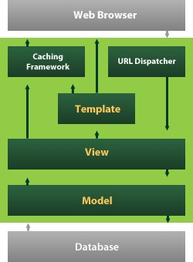

Fig 5.2 Django

Django also provides an optional administrative create, read, update and delete interface that is generated dynamically through introspection and configured via admin models

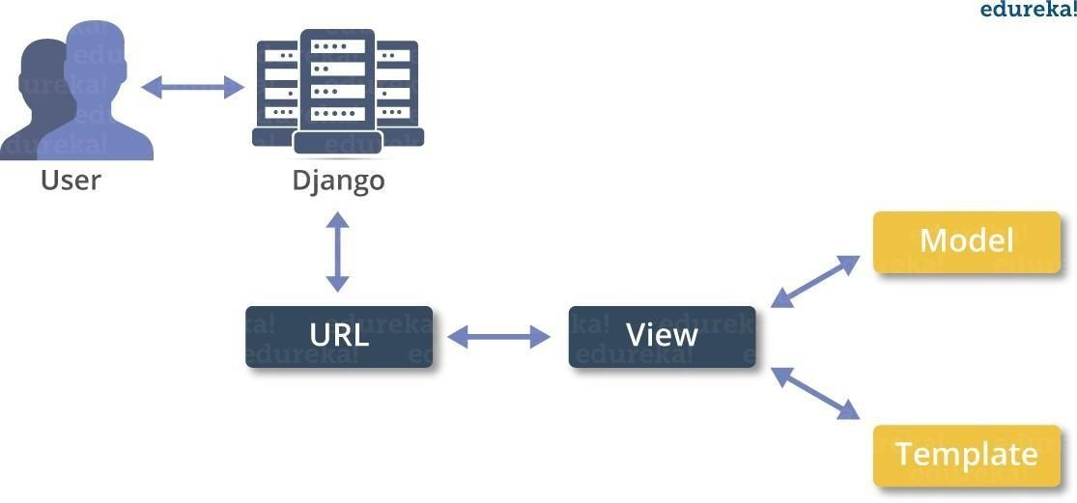

Despite having its own nomenclature, such as naming the callable objects generating the HTTP responses "views", the core Django framework can be seen as an MVC architecture. It consists of an object-relational mapper (ORM) that mediates between data models(defined as Python classes) and a relational database ("Model"), a system for processing HTTP requests with a web templating system("View"), and a regular-expression-based URL dispatcher ("Controller"). Also included in the core framework are:

- a lightweight and standalone web server for development and testing
- a form serialization and validation system that can translate between HTML forms and values suitable for storage in the database
- a template system that utilizes the concept of inheritance borrowed from object-oriented programming
- a caching framework that can use any of several cache method
- support for middleware classes that can intervene at various stages of request processing and carry out custom functions
- an internal dispatcher system that allows components of an application to communicate events to each other via pre-defined signals
- an internationalization system, including translations of Django's own components into a variety of languages
- a serialization system that can produce and read XML and/or JSON representations of Django model instances
- a system for extending the capabilities of the template engine
- an interface to Python's built-in unit test framework

Django's configuration system allows third party code to be plugged into a regular project, provided that it follows the reusable app conventions. More than 2500 packages are available to extend the framework's original behavior, providing solutions to issues the original tool didn't tackle: registration, search, API provision and consumption, CMS, etc.

This extensibility is, however, mitigated by internal components dependencies. While the Django philosophy implies loose coupling, the template filters and tags assume one engine implementation, and both the auth and admin bundled applications require the use of the internal ORM. None of these filters or bundled apps are mandatory to run a Django project, but reusable apps tend to depend on them, encouraging developers to keep using the official stack in order to benefit fully from the apps ecosystem
Django can be run in conjunction with Apache, Nginx using WSGI, Gunicorn, or Cherokee using flup (a Python module). Django also includes the ability to launch a FastCGIserver, enabling use behind any web server which supports FastCGI, such as Lighttpd or Hiawatha. It is also possible to use other WSGI-compliant web servers. Django officially supports four database backends: PostgreSQL, MySQL, SQLite, and Oracle. Microsoft SQL Server can be used with django-mssql on Microsoft operating systems, while similarly external backends exist for IBM Db2, SQL Anywhere and Firebird. There is a fork named django-nonrel, which supports NoSQL databases, such as MongoDB and Google App Engine's Datastore.
Django may also be run in conjunction with Jython on any Java EE application server such as GlassFish or JBoss. In this case django-jython must be installed in order to provide JDBC drivers for database connectivity, which also can provide functionality to compile Django in to a .war suitable for deployment.

Google App Engine includes support for Django version 1.x.x as one of the bundled frameworks.

For developing a Django project, no special tools are necessary, since the source code can be edited with any conventional text editor. Nevertheless, editors specialized on computer programming can help increase the productivity of development, e.g., with features such as syntax highlighting. Since Django is written in Python, text editors which are aware of Python syntax are beneficial in this regard.
Integrated development environments (IDE) add further functionality, such as debugging, refactoring, and unit testing. As with plain editors, IDEs with support for Python can be beneficial. Some IDEs that are specialized on Python
additionally have integrated support for Django projects, so that using such an IDE when developing a Django project can help further increase productivity.
Django is a free and open source Python web framework that helps to develop maintainable and secured websites rapidly. It deals with the difficulties of web development, so you can completely focus on building your application. The Django
project's performance, community, and stability have grown excessively over the past decade.

Django is compatible with all the projects irrespective of its size, whether it is small or big one. Because of its scalability, it is ideal for startups and also serves extraordinary for sites with hundreds of users a moment, like or Disqus.

Some of the popular websites functioned by Django web framework are Pinterest, Instagram, Mozilla Support, Reddit Gifts, Coordinato, Chess etc.

Python Development Steps : -
Guido Van Rossum published the first version of Python code (version 0.9.0) at alt.sources in February 1991. This release included already exception handling, functions, and the core data types of list, dict, str and others. It was also object oriented and had a module system.
Python version 1.0 was released in January 1994. The major new features included in this release were the functional programming tools lambda, map, filter and reduce, which Guido Van Rossum never liked.Six and a half years later in October 2000, Python 2.0 was introduced. This release included list comprehensions, a full garbage collector and it was supporting unicode.Python flourished for another 8 years in the versions 2.x before the next major release as Python 3.0 (also known as "Python 3000" and "Py3K") was released. Python 3 is not backwards compatible with Python 2.x. The emphasis in Python 3 had been on the removal of duplicate programming constructs and modules, thus fulfilling or coming close to fulfilling the 13th law of the Zen of Python: "There should be one -- and preferably only one -- obvious way to do it."Some changes in Python 7.3:
- Print is now a function
- Views and iterators instead of lists
- The rules for ordering comparisons have been simplified. E.g. a heterogeneous list cannot be sorted, because all the elements of a list must be comparable to each other.
- There is only one integer type left, i.e. int. long is int as well.
- The division of two integers returns a float instead of an integer. "//" can be used to have the "old" behaviour.
- Text Vs. Data Instead Of Unicode Vs. 8-bit
Purpose :-
We demonstrated that our approach enables successful segmentation of intra-retinal layers—even with low-quality images containing speckle noise, low contrast, and different intensity ranges throughout—with the assistance of the ANIS feature.
Python
Python is an interpreted high-level programming language for general-purpose programming. Created by Guido van Rossum and first released in 1991, Python has a design philosophy that emphasizes code readability, notably using significant whitespace.
Python features a dynamic type system and automatic memory management. It supports multiple programming paradigms, including object-oriented, imperative, functional and procedural, and has a large and comprehensive standard library.
- Python is Interpreted − Python is processed at runtime by the interpreter. You do not need to compile your program before executing it. This is similar to PERL and PHP.
- Python is Interactive − you can actually sit at a Python prompt and interact with the interpreter directly to write your programs.
Python also acknowledges that speed of development is important. Readable and terse code is part of this, and so is access to powerful constructs that avoid tedious repetition of code. Maintainability also ties into this may be an all but useless metric, but it does say something about how much code you have to scan, read and/or understand to troubleshoot problems or tweak behaviors. This speed of development, the ease with which a programmer of other languages can pick up basic Python skills and the huge standard library is key to another area where Python excels. All its tools have been quick to implement, saved a lot of time, and several of them have later been patched and updated by people with no Python background - without breaking.
Modules Used in Project :-
Tensorflow
TensorFlow is a free and open-source software library for dataflow and differentiable programming across a range of tasks. It is a symbolic math library, and is also used for machine learning applications such as neural networks. It is used for both research and production at Google.‍
TensorFlow was developed by the Google Brain team for internal Google use. It was released under the Apache 2.0 open-source license on November 9, 2015.
Numpy
Numpy is a general-purpose array-processing package. It provides a high-performance multidimensional array object, and tools for working with these arrays.
It is the fundamental package for scientific computing with Python. It contains various features including these important ones:
- A powerful N-dimensional array object
- Sophisticated (broadcasting) functions
- Tools for integrating C/C++ and Fortran code
- Useful linear algebra, Fourier transform, and random number capabilities
Besides its obvious scientific uses, Numpy can also be used as an efficient multi-dimensional container of generic data. Arbitrary data-types can be defined using Numpy which allows Numpy to seamlessly and speedily integrate with a wide variety of databases.
Pandas
Pandas is an open-source Python Library providing high-performance data manipulation and analysis tool using its powerful data structures. Python was majorly used for data munging and preparation. It had very little contribution towards data analysis. Pandas solved this problem. Using Pandas, we can accomplish five typical steps in the processing and analysis of data, regardless of the origin of data load, prepare, manipulate, model, and analyze. Python with Pandas is used in a wide range of fields including academic and commercial domains including finance, economics, Statistics, analytics, etc.
Matplotlib
Matplotlib is a Python 2D plotting library which produces publication quality figures in a variety of hardcopy formats and interactive environments across platforms. Matplotlib can be used in Python scripts, the Python and IPython shells, the Jupyter Notebook, web application servers, and four graphical user interface toolkits. Matplotlib tries to make easy things easy and hard things possible. You can generate plots, histograms, power spectra, bar charts, error charts, scatter plots, etc., with just a few lines of code. For examples, see the sample plots and thumbnail gallery.
For simple plotting the pyplot module provides a MATLAB-like interface, particularly when combined with IPython. For the power user, you have full control of line styles, font properties, axes properties, etc, via an object oriented interface or via a set of functions familiar to MATLAB users.
Scikit – learn
Scikit-learn provides a range of supervised and unsupervised learning algorithms via a consistent interface in Python. It is licensed under a permissive simplified BSD license and is distributed under many Linux distributions, encouraging academic and commercial use. Python
Python is an interpreted high-level programming language for general-purpose programming. Created by Guido van Rossum and first released in 1991, Python has a design philosophy that emphasizes code readability, notably using significant whitespace.
Python features a dynamic type system and automatic memory management. It supports multiple programming paradigms, including object-oriented, imperative, functional and procedural, and has a large and comprehensive standard library.
- Python is Interpreted − Python is processed at runtime by the interpreter. You do not need to compile your program before executing it. This is similar to PERL and PHP.
- Python is Interactive − you can actually sit at a Python prompt and interact with the interpreter directly to write your programs.
Python also acknowledges that speed of development is important. Readable and terse code is part of this, and so is access to powerful constructs that avoid tedious repetition of code. Maintainability also ties into this may be an all but useless metric, but it does say something about how much code you have to scan, read and/or understand to troubleshoot problems or tweak behaviors. This speed of development, the ease with which a programmer of other languages can pick up basic Python skills and the huge standard library is key to another area where Python excels. All its tools have been quick to implement, saved a lot of time, and several of them have later been patched and updated by people with no Python background - without breaking.
Install Python Step-by-Step in Windows and Mac :
Python a versatile programming language doesn’t come pre-installed on your computer devices. Python was first released in the year 1991 and until today it is a very popular high-level programming language. Its style philosophy emphasizes code readability with its notable use of great whitespace.
The object-oriented approach and language construct provided by Python enables programmers to write both clear and logical code for projects. This software does not come pre-packaged with Windows.

CHAPTER – 6

SOFTWARE INSTALLATION

There have been several updates in the Python version over the years. The question is how to install Python? It might be confusing for the beginner who is willing to start learning Python but this tutorial will solve your query. The latest or the newest version of Python is version 3.7.4 or in other words, it is Python 3.
Note: The python version 3.7.4 cannot be used on Windows XP or earlier devices.

Before you start with the installation process of Python. First, you need to know about your System Requirements. Based on your system type i.e. operating system and based processor, you must download the python version. My system type is a Windows 64-bit operating system. So the steps below are to install python version 3.7.4 on Windows 7 device or to install Python 3. Download the Python Cheatsheet here.The steps on how to install Python on Windows 10, 8 and 7 are divided into 4 parts to help understand better.

Download the Correct version into the system

Step 1: Go to the official site to download and install python using Google Chrome or any other web browser. OR Click on the following link: https://www.python.org

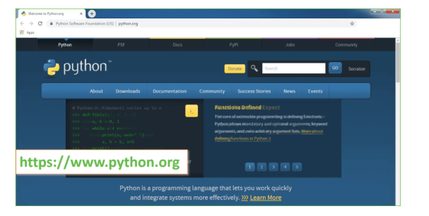
Now, check for the latest and the correct version for your operating system.
Step 2: Click on the Download Tab.
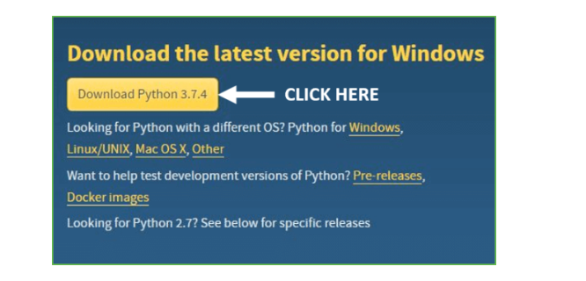
Step 3: You can either select the Download Python for windows 3.7.4 button in Yellow Color or you can scroll further down and click on download with respective to their version. Here, we are downloading the most recent python version for windows 3.7.4
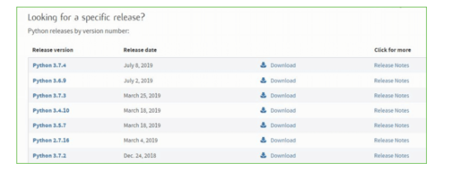
Step 4: Scroll down the page until you find the Files option.

Step 5: Here you see a different version of python along with the operating system.

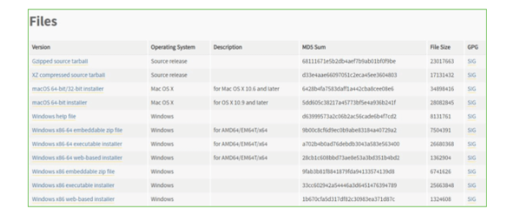

python
• To download Windows 32-bit, you can select any one from the three options: Windows x86 embeddable zip file, Windows x86 executable installer or Windows x86 web-based installer.
•To download Windows 64-bit python, you can select any one from the three options: Windows x86-64 embeddable zip file, Windows x86-64 executable installer or Windows x86-64 web-based installer.
Here we will install Windows x86-64 web-based installer. Here your first part regarding which version of python is to be downloaded is completed. Now we move ahead with the second part in installing python i.e. Installation
Note: To know the changes or updates that are made in the version you can click on the Release Note Option.

Installation of Python
Step 1: Go to Download and Open the downloaded python version to carry out the installation process.
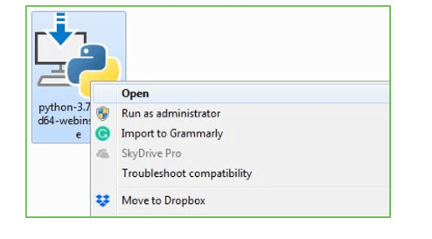

Step 2: Before you click on Install Now, Make sure to put a tick on Add Python 3.7 to
PATH.

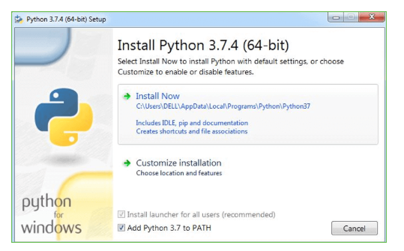

Step 3: Click on Install NOW After the installation is successful. Click on Close.

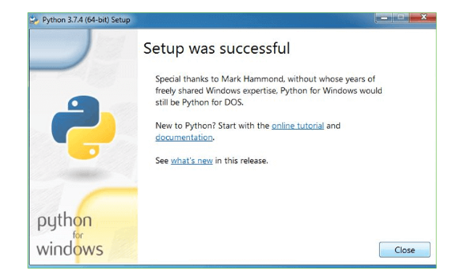

With these above three steps on python installation, you have successfully and correctly installed Python. Now is the time to verify the installation.
Note: The installation process might take a couple of minutes.

Verify the Python Installation
Step 1: Click on Start
Step 2: In the Windows Run Command, type “cmd”.

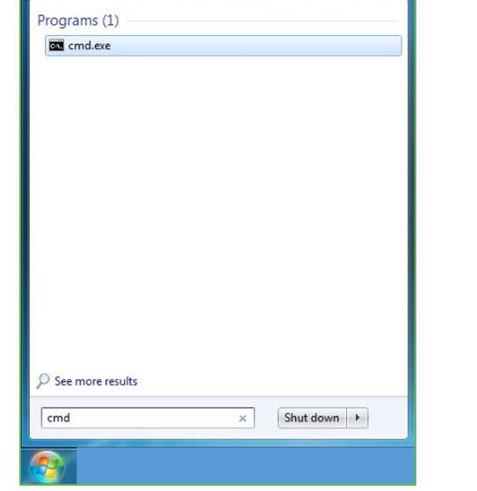
Step 3: Open the Command prompt option.
Step 4: Let us test whether the python is correctly installed. Type python –V and press Enter.

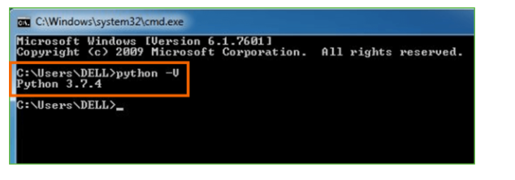
Step 5: You will get the answer as 3.7.4
Note: If you have any of the earlier versions of Python already installed. You must first uninstall the earlier version and then install the new one.

Check how the Python IDLE works
Step 1: Click on Start
Step 2: In the Windows Run command, type “python idle”.
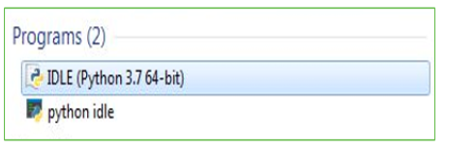

Step 3: Click on IDLE (Python 3.7 64-bit) and launch the program
Step 4: To go ahead with working in IDLE you must first save the file. Click on File > Click on Save

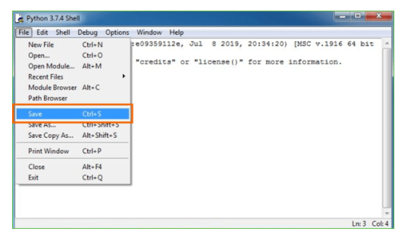

Step 5: Name the file and save as type should be Python files. Click on SAVE. Here I have named the files as Hey World.
Step 6: Now for e.g. enter print
Libraries installed in Project

1.pip install numpy==1.18.1
2.pip install matplotlib==3.1.3
3. pip install pandas==0.25.3
4.pip install opencv-python==4.2.0.32
5. pip install keras==2.3.1
6. Pip install tensorflow==1.14.0
7. pip install h5py==2.10.0
8. pip install pillow==7.0.0
9. pip install sklearn-genetic==0.2
10. pip install swarmpackagepy
11. pip install sklearn
12. pip install scikit-learn==0.22.2.post1
13. pip install sklearn-extensions==0.0.2

CHAPTER – 7

CODING

from tkinter import messagebox
from tkinter import *
from tkinter import simple dialog
import tkinter
from tkinter import filedialog
from imutils import paths
import numpy as np
from collections import defaultdict
from tkinter.filedialog import askopenfilename
from tkinter import simpledialog
from keras.preprocessing.image import img_to_array
from keras.models import load_model
import imutils
import cv2
import numpy as np
import sys
from tkinter import ttk
import os

main = tkinter.Tk()
main.title("Displaying Emoji Based Facial Expressions")
main.geometry("1200x1200")

global value
global filename
global faces
global frame
detection_model_path = 'models/haarcascade_frontalface_default.xml'
emotion_model_path = 'models/_mini_XCEPTION.106-0.65.hdf5'
face_detection = cv2.CascadeClassifier(detection_model_path)
emotion_classifier = load_model(emotion_model_path, compile=False)
EMOTIONS = ["angry","disgust","scared", "happy", "sad", "surprise","neutral"]
global songslist

def upload():
global filename
global value
filename = askopenfilename(initialdir = "images")
pathlabel.config(text=filename)

def preprocess():
global filename
global frame
global faces
text.delete('1.0', END)
orig_frame = cv2.imread(filename)
orig_frame = cv2.resize(orig_frame, (48, 48))
frame = cv2.imread(filename,0)
faces = face_detection.detectMultiScale(frame,scaleFactor=1.1,minNeighbors=5,minSize=(30,30),flags=cv2.CASCADE_SCALE_IMAGE)
text.insert(END,"Total number of faces detected : "+str(len(faces)))

def detectExpression():
global faces
if len(faces) > 0:
faces = sorted(faces, reverse=True,key=lambda x: (x[2] - x[0]) * (x[3] - x[1]))[0]
(fX, fY, fW, fH) = faces
roi = frame[fY:fY + fH, fX:fX + fW]
roi = cv2.resize(roi, (48, 48))
roi = roi.astype("float") / 255.0
roi = img_to_array(roi)
roi = np.expand_dims(roi, axis=0)
preds = emotion_classifier.predict(roi)[0]
emotion_probability = np.max(preds)
label = EMOTIONS[preds.argmax()]
img = cv2.imread('Emoji/'+label+".png")
img = cv2.resize(img, (600,400))
cv2.putText(img, "Facial Expression Detected As : "+label, (10, 25), cv2.FONT_HERSHEY_SIMPLEX,0.7, (0, 0, 255), 2)
cv2.imshow("Facial Expression Detected As : "+label, img)
cv2.waitKey(0)
else:
messagebox.showinfo("Facial Expression Prediction Screen","No face detceted in uploaded image")

def detectfromvideo(image):
result = 'none'
temp = image
gray = cv2.cvtColor(image, cv2.COLOR_BGR2GRAY)
faces = face_detection.detectMultiScale(gray,scaleFactor=1.1, minNeighbors=5, minSize=(30, 30), flags = cv2.CASCADE_SCALE_IMAGE)
print("Found {0} faces!".format(len(faces)))
output = "none"
if len(faces) > 0:
faces = sorted(faces, reverse=True,key=lambda x: (x[2] - x[0]) * (x[3] - x[1]))[0]
(fX, fY, fW, fH) = faces
roi = temp[fY:fY + fH, fX:fX + fW]
roi = cv2.cvtColor(roi, cv2.COLOR_BGR2GRAY)
roi = cv2.resize(roi, (48, 48))
roi = roi.astype("float") / 255.0
roi = img_to_array(roi)
roi = np.expand_dims(roi, axis=0)
preds = emotion_classifier.predict(roi)[0]
emotion_probability = np.max(preds)
label = EMOTIONS[preds.argmax()]
output = label
return output

def detectWebcamExpression():
cap = cv2.VideoCapture(0)
while True:
_, img = cap.read()
height, width, channels = img.shape
result = detectfromvideo(img)
if result != 'none':
print(result)
img1 = cv2.imread('Emoji/'+result+".png")
img1 = cv2.resize(img1, (width,height))
cv2.putText(img1, "Facial Expression Detected As : "+result, (10, 25), cv2.FONT_HERSHEY_SIMPLEX,0.7, (0, 255, 0), 2)
cv2.imshow("Emoji Output",img1)
cv2.putText(img, "Facial Expression Detected As : "+result, (10, 25), cv2.FONT_HERSHEY_SIMPLEX,0.7, (0, 255, 0), 2)
cv2.imshow("Facial Expression Output", img)
if cv2.waitKey(650) & 0xFF == ord('q'):
break
cap.release()
cv2.destroyAllWindows()

font = ('times', 20, 'bold')
title = Label(main, text='Displaying Emoji Based Facial Expressions')
title.config(bg='brown', fg='white')
title.config(font=font)
title.config(height=3, width=80)
title.place(x=5,y=5)

font1 = ('times', 14, 'bold')
upload = Button(main, text="Upload Image With Face", command=upload)
upload.place(x=50,y=100)
upload.config(font=font1)

pathlabel = Label(main)
pathlabel.config(bg='brown', fg='white')
pathlabel.config(font=font1)
pathlabel.place(x=300,y=100)

preprocessbutton = Button(main, text="Preprocess & Detect Face in Image", command=preprocess)
preprocessbutton.place(x=50,y=150)
preprocessbutton.config(font=font1)

emotion = Button(main, text="Detect Facial Expression", command=detectExpression)
emotion.place(x=50,y=200)
emotion.config(font=font1)

emotion = Button(main, text="Detect Facial Expression from WebCam", command=detectWebcamExpression)
emotion.place(x=50,y=250)
emotion.config(font=font1)

font1 = ('times', 12, 'bold')
text=Text(main,height=10,width=150)
scroll=Scrollbar(text)
text.configure(yscrollcommand=scroll.set)
text.place(x=10,y=300)
text.config(font=font1)

main.config(bg='brown')
main.mainloop()

CHAPTER – 8

TESTING

8.1 INTRODUCTION TO TESTING

Software testing is a critical element of software quality assurance and represents the ultimate reviews of specification, design and coding. Testing presents an interesting anomaly of the software. During earlier definition and development phases, it was attempted to build software from abstract concept to a tangible implementation.
The testing phase involves the testing of the developed system using various set data. Presentation of test data plays a vital role in system testing. After preparing the test data the system under study was tested using test data. While testing the system by using test data errors were found and corrected. A series of tests were performed for the proposed system before the system was ready for implementation. The various types of testing done on the system are:

- Unit Testing
- Integration Testing
- User Acceptance Testing
- System Testing

8.2 Unit Testing

Unit testing focuses verification effort on the smallest unit of software design, the module. It comprises the set of test performed by the programmer prior to integration of the unit into larger system. The testing was carried out during the coding stage itself. In this step each module is found to be working satisfactorily as regards to the expected output from the module.
Each form is treated as a unit and tested thoroughly for bugs. The following is a list of some of the test cases :

1) In the login form, if a member does not enter a value for userId and password, then the user is prompted with the error message “userId and password should not be blank”.
2) In the login form, if a member enters wrong values for userId and password, then the user is prompted with the error message “Invalid userId and password. Try again.”.
3) In book Entry screen and new student, teacher screen, all the fields should have a value. Otherwise, the user is prompted with an appropriate error messages.
4) In book transactions form, member id, book no,. issue date, and return date are mandatory. If not provided, then the system will prompt the user with the error message “Fields should not be blank”.

8.3 Integration Testing

Integration testing is a systematic technique for constructing the program structure while at the same time conducting tests to uncover error associated within the interface. The objective is to take unit tested modules and build a program structure that has been dictated by design. All modules are combined in this step. The entire program is tested as whole. And chaos in interfaces may usually result. A set of errors is encountered in such a case.

The integration testing can be carried out using two methodologies:

# Top Down Integration
# Bottom Up Integration

The first one is done where integration is carried out by addition of major modules to minor modules. While Bottom Up integration follows combination of smaller ones to larger one. Here, Bottom Up Integration is followed. Even though correction was difficult because the isolation of causes is complicated by the vastness of the entire program, all the errors found in the system were corrected and then forwarded to the next testing steps.
The navigation among all the screens have been thoroughly verified so that the user of the system can move from one form to another form.
The connectivity between the forms and the database has been checked. In case of any malfunctions, the user will be informed about the problem.

8.4 User Acceptance Testing

User acceptance of a system is the key factor for the success of any system. The system under consideration was tested for users acceptance by constantly keeping in touch with the perspective system user at the time of developing and making changes wherever required. This is done with the regards to the following points:
A system may be defined as a set of instructions combined in the same form and directed to some purpose.
Before any development is undertaken certain specifications are prepared which objectively describe the application system. The System specifications are made after consulting the end user managers of the relevant departments.
Software to be developed is planned on the basis of requirement of the user. The problem definition statement description of present situation and goal to be achieved by news system.
The success of system depends on how accurately a problem is defined, thoroughly investigated carried out through choice of solution. User need identification and analysis that are concerned with what the uses needs rather than what he/she wants. System explains how to perform specific activities or task, which does what and what.

8.5 System Testing

Testing the behavior of the whole software/system as defined in software requirements specification(SRS) is known as system testing, its main focus is to verify that the customer requirements are fulfilled.
System testing is done after integration testing is complete. System testing should test functional and non functional requirements of the software. The test types followed in system testing differ from organization to organization.
The project is executed and tested on the machines that satisfy the given hardware and software requirements. It was executed successfully with the specified hardware and operating system

8.6 Test Cases
USER REQUIREMENTS:
1.Home

Home:
Use case ID | Detection of Non-Helmet Riders and Extraction of License Plate Number using Yolo v2 and OCR Method
Use case Name | Home button
Description | Display home page of application
Primary actor | User
Precondition | User must open application
Post condition | Display the Home Page of an application
Frequency of Use case | Many times
Alternative use case | N/A
Use case Diagrams
Attachments | N/A

CHAPTER – 9

RESULTS

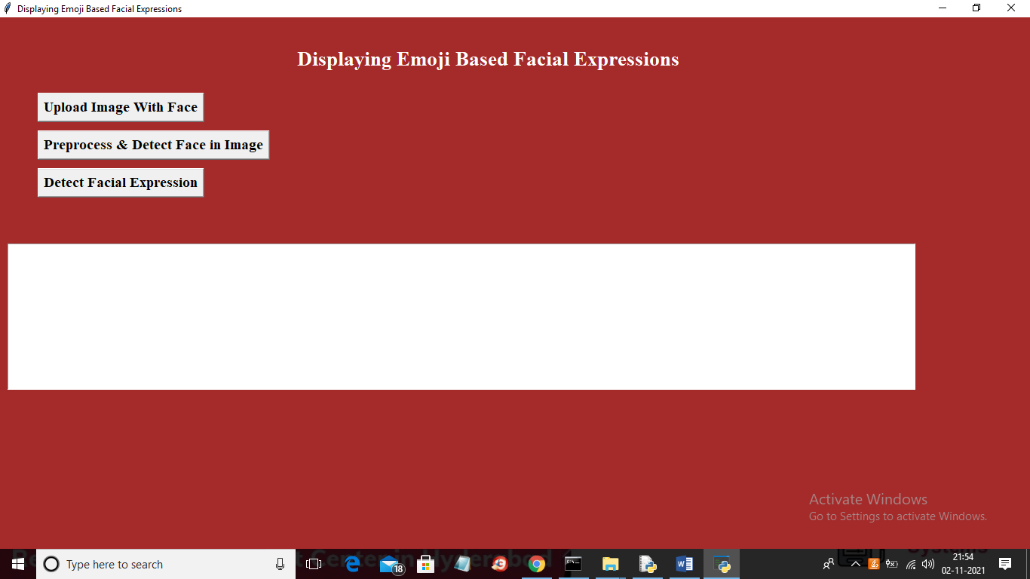

Fig: 9.2 Output screen-1

In above screen click on ‘Upload Image with Face’ button to upload image

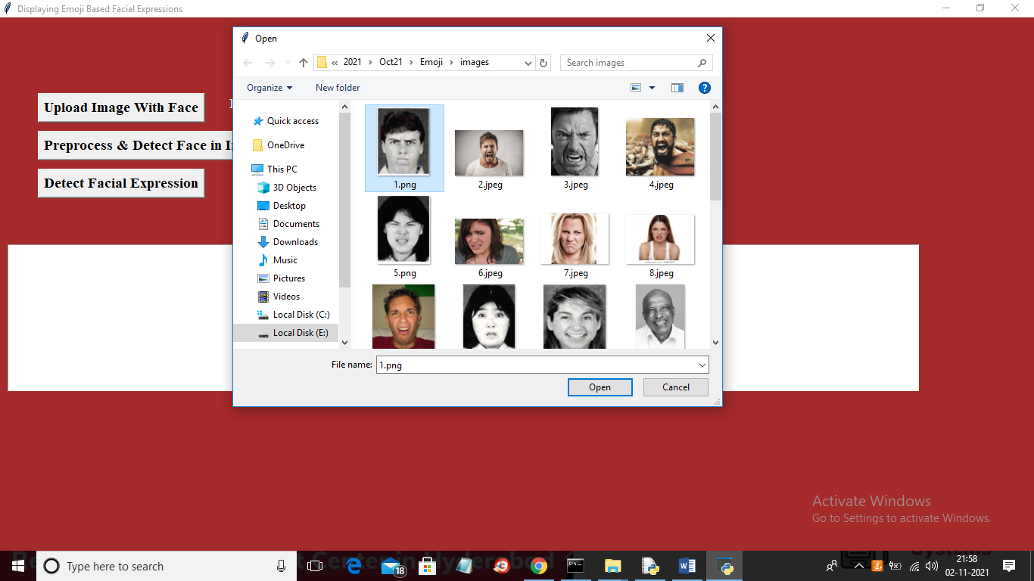

Fig: 9.3 Output Screen -2

In above screen selecting and uploading ‘1.png’ file and then click on ‘Open’ button to load image and to get below output

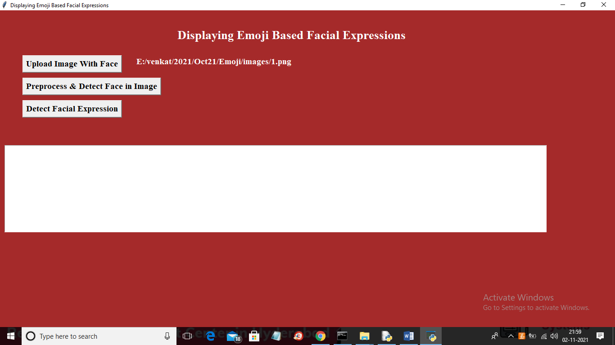

Fig 9.2 Output Screen-3

In above screen image is loaded and now click on ‘Preprocess & Detect Face in Image’ button to check whether image contains human face or not

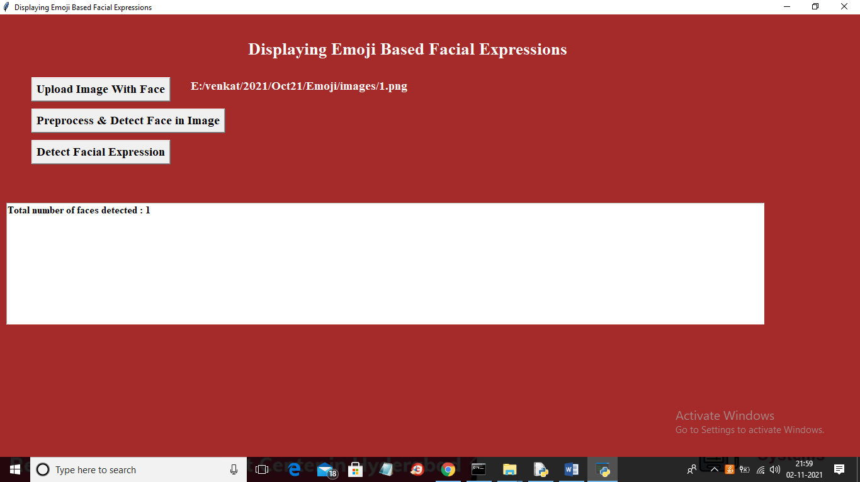

Fig 9.2 Output Screen-4

In above screen in text are we can see one face is detected and now click on ‘Detect Facial Expression’ button to detect facial expression and to get below output

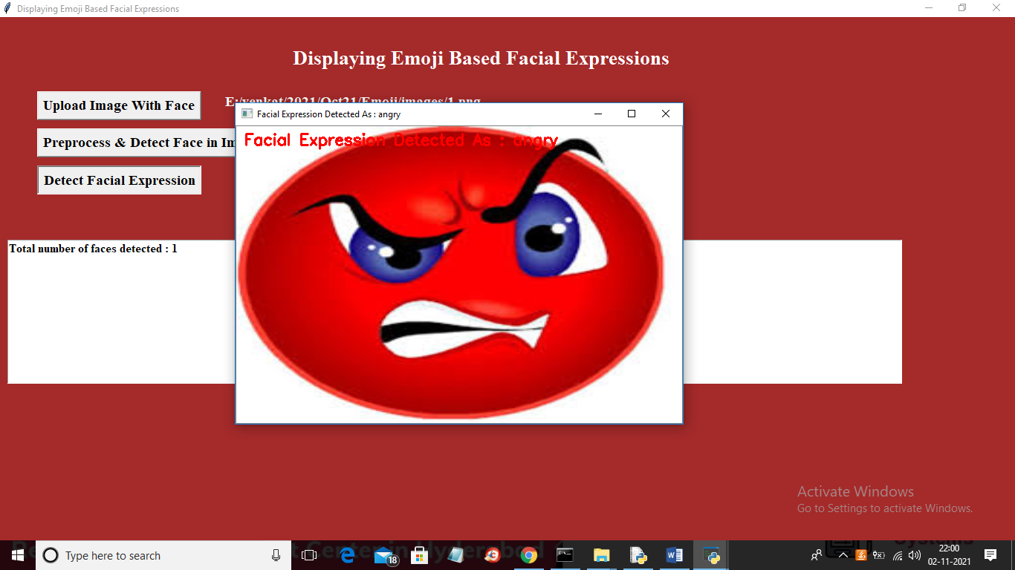

Fig: 9.2 Output Screen -5

In above screen in uploaded image expression detected as ANGRY and then ANGRY Emoji is displayed and below is the other output

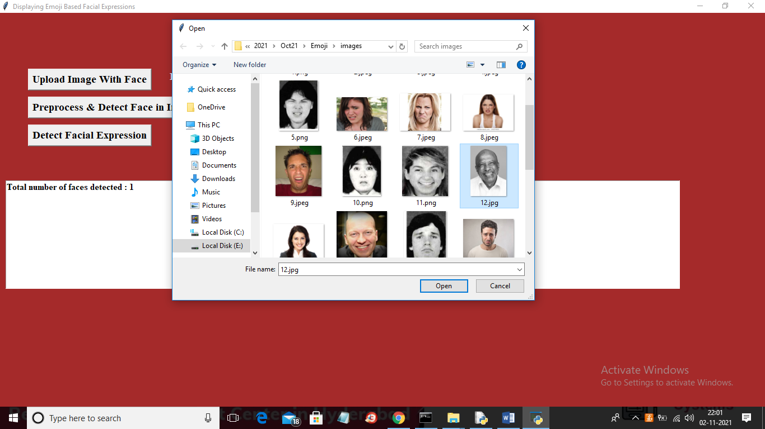

Fig 9.2 Output Screen-6

In above screen uploading 12.jpg file and then preprocess image and then click on ‘Detect Facial Expression’ button to get below output

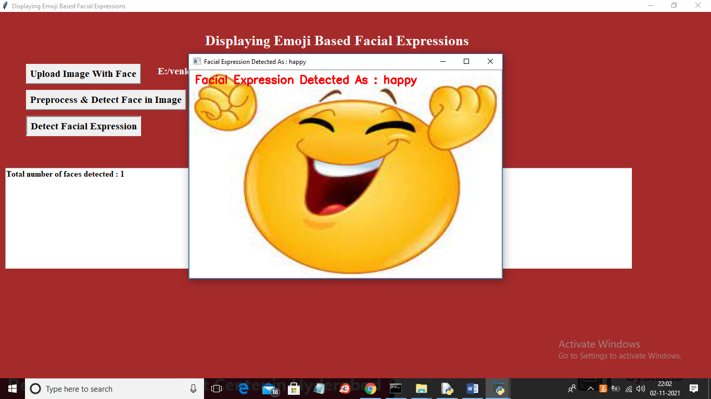

Fig: 9.7 output screen-7

CHAPTER – 10

ONCLUSION

In this paper, Computer Vision has been used for the recognition of facial emotion and converting those emotions into their corresponding emoticons.
Object face is detected using any camera-based API. The Features of the expressions of the detected face will be extracted using HAAR cascade that will supply the feature extractions of the expressions depicted in the image for further classification into seven emotions by employing Support Vector Machines (SVM) that exhibits a good accuracy value as compared to the other existing algorithms.
This proposed model can be used by the leading social networking handlers like Facebook, Instagram, Snapchat for their camera-based applications involving various effects and filters.
There are many existing face-detecting neural networks that have good efficiency but their implementation may be difficult in some cases.
Through our approach of using APIs instead of neural networks, we can make the implementation convenient.

CHAPTER 11
REFERENCES

1. (Burgoon, J., Guerrero, L., Floyd, K., (2010). Nonverbal Communication, Taylor & Francis. p.3)

2. Carton, J.S., Kessler, E.A., Pape, C.L.: Nonverbal decoding skills and relationship well-being in adults. J. Nonverbal Behav. 23(1), 91–100 (1999)

3. Izard, C.E.: Human Emotions. Springer, New York (2013)

4. Lewine, Donald A. (1991). POSIX Programmer's Guide (PDF). O'Reilly & Associates, Inc. p. 1. Retrieved 2 August 2016.

5. Clarke, Steven (2004). "Measuring API Usability". Dr. Dobb's. Retrieved 29 July 2016.

